Confidence Intervals and Hypothesis Testing
In the workshop 8 we continue to use the 2009 Australian Survey of Social Attitudes (AuSSA). This workshop introduces how to estimate confidence intervals and how to conduct a t test of sample means.

Create a Confidence Interval

Confidence Intervals for Continuous Variables
Suppose that we want to estimate 95% confidence intervals of respondents’ age in the 2009 AuSSA.
To create a confidence interval, 1) go to Analyze > Descriptive Statistics > Explore. In the popped-up box, 2) select a continuous variable (in this case age) for which you want to estimate a confidence interval and move it to the box of Dependent List. 3) Click Statistics. (See <Figure 1>)
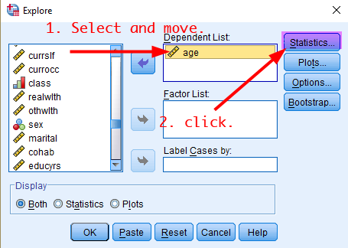
<Figure 1>
Then, in the popped-up box, 4) tick Descriptives and 5) type confidence levels (in our case 95) in Confidence Interval for Mean. 6) Click Continue.

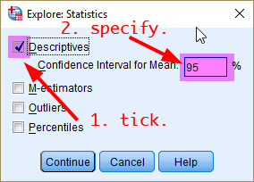
<Figure 2>
In the previous box, click OK. It will show the 95% confidence interval of respondents’ age.
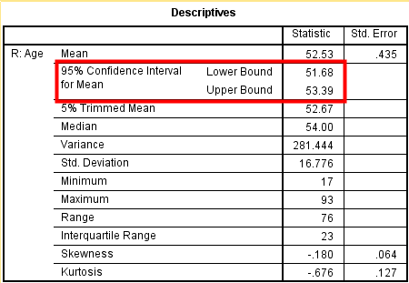
<Table 1>

Confidence Intervals by a Group
Suppose that we want to estimate 95% confidence intervals of respondents’ age for males and females respectively. Go to Analyze > Descriptive Statistics > Explore. In the popped-up box, put age in the Dependent List and sex in the Factor List (see <Figure 3>).
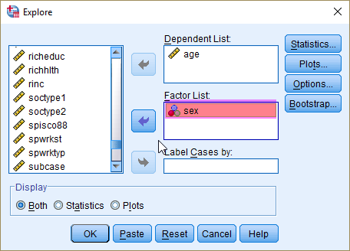
<Figure 3>
Click Statistics. Do the same thing as you did in the last section. It will show the 95% confidence intervals of age for male and female respondents, respectively.
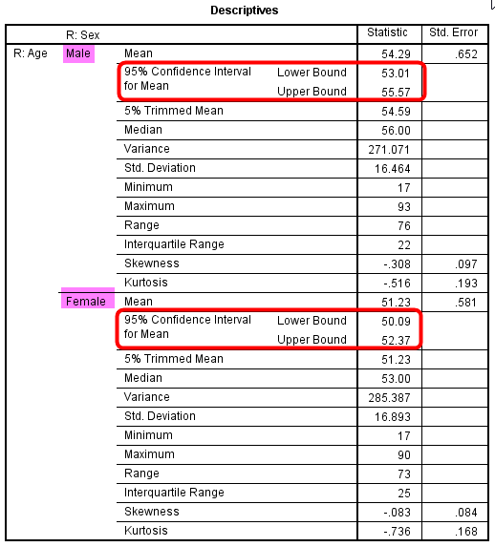
<Table 2>

Confidence Intervals for a Proportion
When you want to compute confidence intervals for a categorical (nominal or ordinal) variable, you first need to dichotomize the variable so that you can calculate a proportion of a category. Suppose that we are estimating the 95% confidence interval for the proportion of people who agree the importance of coming from a wealthy family (opwlth).
First, we need to dichotomize the opwlth variable using Recode into Different Variables. <Table 3> shows the recoding scheme of the new variable (newopwlth)
opwlth |  | newopwlth
values | labels | values | Labels
1 | Essential | 1 | Important
2 | Very important
3 | Fairly important
4 | Not very important | 0 | Not important
5 | Not important at all
<Table 3>
Then, follow the same procedure as you did in 1.1. <Figure 4> would be helpful.
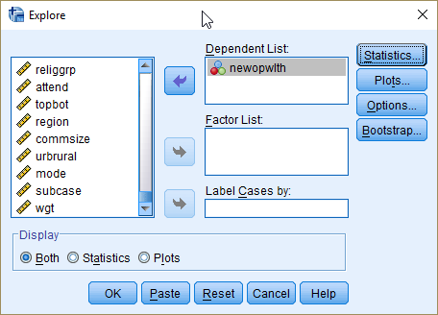
<Figure 4>
<Table 4> shows the final output.
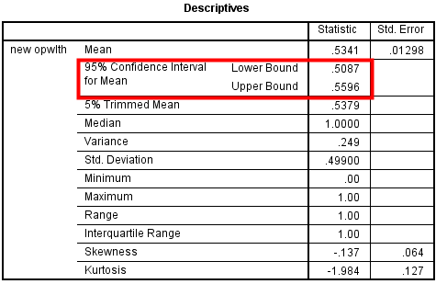
<Table 4>
If you put the sex variable in the Factor List in <Figure 4>, you will get the 95% confidence intervals for the proportion for male and female respondents, separately (see <Table 5>).
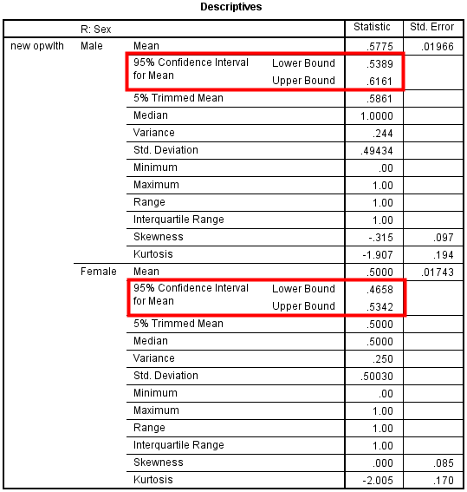
<Table 5>

Visualising Confidence Intervals
In this section, we are going to visualize the confidence intervals for the proportion of people who agree the importance of coming from a wealth family (newopwlth) by gender (sex).
1) Go to Graph > Legacy Dialogs > Error Bar. In the popped-up box, 2) select Simple and Summaries for groups of cases. 3) Click Define. (see <Figure 5>)
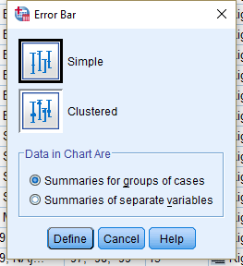
<Figure 5>
In the popped-up box (see <Figure 6>), 4) move newopwlth into Variable. 5) choose sex as Category Axis and then 6) Click OK.
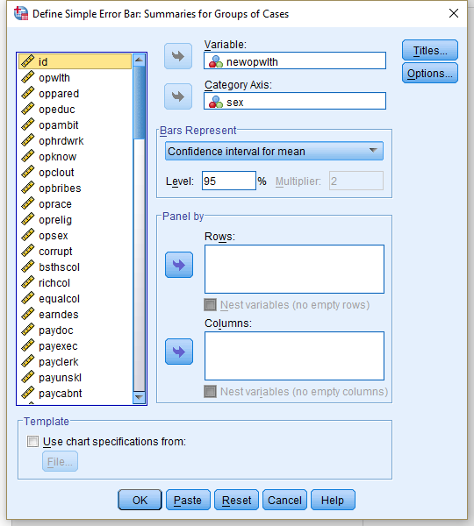
<Figure 6>
It will produce <Figure 7>. Do you think men and women assess differently the importance of wealthy family backgrounds?
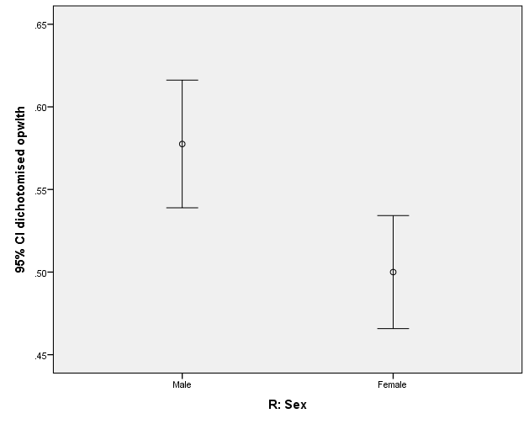
<Figure 7>

Hypothesis Testing

One-Sample t-Test
The standard working hours per week in Australia is currently 38. Let’s test whether Australians work on average 38 hours per week or not using the wrkhrs variable. We will test whether the average working hours of Australians from the 2012 Australian attitude of social survey is significantly different from 38 hours. Thus, our research hypothesis is that Australians work on average more than or less than 38 hours per week, and the null hypothesis is that Australians work on average 38 hours per week.
To conduct one-sample t-test, 1) go to Analyze > Compare Mean > One-Sample T Test. In the popped-up box 2) move a variable of your interest (in this case wrkhrs) and 3) specify a test value which the null hypothesis indicates (in this case 38).
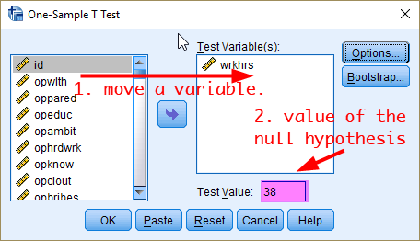
<Figure 8>
Then, 4) click OK. It will show <Table 6> which provides the sample mean, the difference from the null hypothesis value, t statistic and its associated p-value. Based on <Table 6>, do you think Australians work on average 38 hours per week?
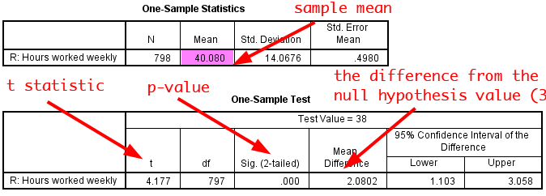
<Table 6>
NOTE) The p-value in SPSS is based on a two-tailed t test. If you want to get p-values for a one-tailed t test, divide the p-value in SPSS by two. For example, if the p-value in SPSS outputs is .05, the p-value for a one-tailed test will be .025

Two-Sample t Test
Suppose that we would like to test whether the average working hours are different between men and women. Thus, the null hypothesis is that there is no gender difference in average working hours. We use two-sample t test because we compare the average working hours between two different groups (men and women).
To conduct two-sample t test, 1) go to Analyze> Compare Means > Independent-Samples T Test. 2) Move a variable of your interest (in this case wrkhrs) to the box of Test Variable(s) and 3) a variable of Groups (in this case sex) to the box of Grouping Variable. 4) Click Define Groups.
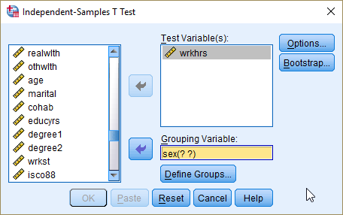
<Figure 9>
In the popped-up box, 5) select Use specified values. And 6) input 1 (male) for Group 1 and 2 (female) for Group 2. 7) Click Continue. In the previous window, 8) click OK.
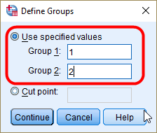
<Figure 10>
It will show <Table 7>.
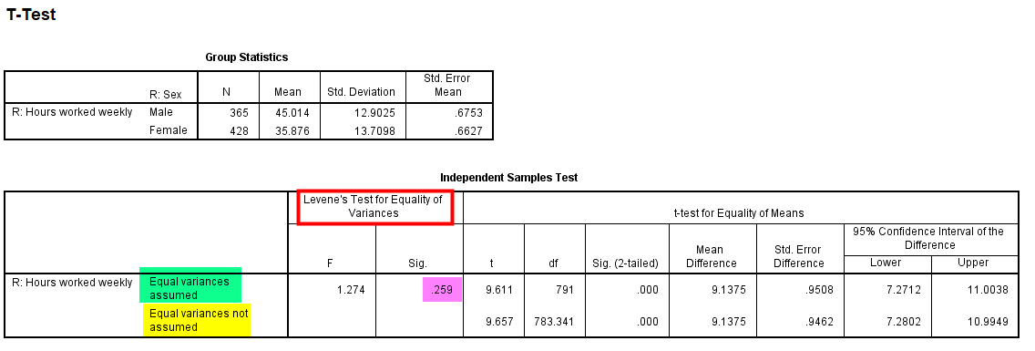
<Table 7>
Group Statistics in <Table 7> show the average working hours for male and female respondents. Independent Samples Test in <Table 7> examines whether the difference (9.1375 = 45.014 – 35.876) is statistically significant.
First, look at the column of Levene’s Test for Equality of Variance. This is a test for equal variances. The null hypothesis is the two distributions (for males and females) have equal variance. Let’s set the significance level .05. The above result shows that p-value (denoted as Sig.) is .259 which is much greater than the significance level (.05). Thus, we cannot reject the null hypothesis that the two distributions have the same variance. Therefore, we conclude that the two distributions have the equal variance.
For this reason, we will use t-test for “Equal variances are assumed” (The 1st row). t-statistic is 9.611 and its p-value is .000. And this p-value is computed based on two-tailed t-test. Again let’s set the significance level (alpha) .05. The p-value is much less than the alpha and thus we reject the null hypothesis that there is no gender difference in working hours per week. Therefore, we conclude that there is a significant difference in working hours per week between men and women.

t Test of Proportion Differences
Suppose that we would like to test whether there is a gender (sex) difference in the proportion of people who agree the importance of coming from a wealthy family (newopwlth). Repeat the same procedure as you did in 2.2, with newopwlth in the box of Test Variable(s) and sex in the box of Grouping Variable.
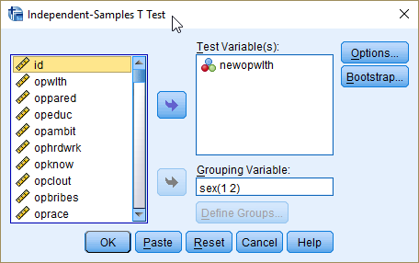
<Figure 11>
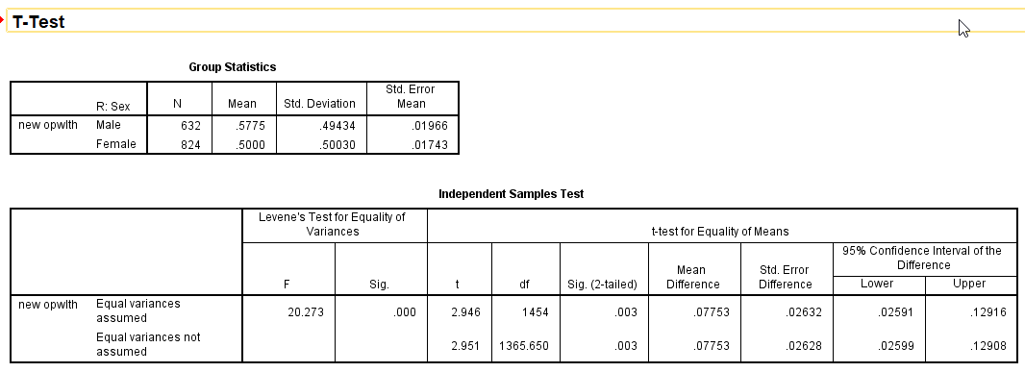
<Table 8>
Levene’s Test in <Table 8> shows the p-value is less than the alpha (α=.05). Therefore, the two distributions have a different variance, which enforces you to use “Equal variances not assumed”. The t-statistic is 2.951 and its p-value (.003) is smaller than .05. So, we can reject the null hypothesis that there is no difference in proportions of people who think of wealthy family backgrounds as important between men and women at alpha = .05 and even alpha = 01.

Workshop Activities
Q1. Public polls often report the percentage of people who support a political party. We are going to do a similar task using the prtyaff variable. This variable asks which political party respondents think is affiliated with. The given choices are:
Value | Label
1 | Liberal Party
2 | Labour Party
3 | National Party
4 | Australian Democrats
5 | Greens
6 | One Nation
7 | Family First
8 | Other party
9 | Would not vote; No party preference

- Compute the 90% confidence interval of the percentage of people who identify themselves as Liberal party supporters. You need to make a new variable which differentiate Liberal party supporters from all the other party supporters.
- Compute the 90% confidence interval of the percentage of people who identify themselves as Labour party supporters. You need to make a new variable which differentiate Labour party supporters from all the other party supporters.
- Based on the 90% confidence intervals, do you think there is a significant difference in terms of the percentage of supporters between Liberal and Labour party?

Q2. Compute the 95% confidence intervals of years of schooling (educyrs) for male and female respondents, respectively. Based on the outcome, do you think there is a significant difference in education between men and women?

Q3. Investigate whether people have on average more or less than 12 years of schooling. Conduct an one-sample t-test using the educyrs variable. Set the significance level at α = .05. What is your conclusion? Do people have 12 years of schooling, or more or less?
Q4. Investigate whether men and women view differently the importance of gender (opsex) and race (oprace) in getting ahead in the Australian society. You need to recode these two variables in the same way as you did for opwlth (see <Table 3>).
- State the research and null hypothesis.
- Will you use a one-tailed or two-tailed test? And explain why.
- Present SPSS outputs of the two-sample t-test. Based on the output, what is your conclusion? Set the significance level at α = .05 for your conclusion. And justify your conclusion using all the necessary information.

