Creating an Index of Attitudes toward Working Women
In this workshop, we will create an index of “Attitudes toward working women”. The index can be created by combining four variables in the 2012 AuSSA:
- fechld: A working mother can establish just as warm and secure a relationship with her children as a mother who does not work.
- fepresch: A preschool child is likely to suffer if his or her mother works.
- famsuffr: All in all, family life suffers when the woman has a full-time job.
- homekid: A job is all right, but what most women really want is a home and children.

These variables measure the degree to which respondents agree or disagree with each statement. Please review each statement carefully. Note that each statement has different meaning regarding the attitude toward working women as agreeing with a statement does not always translate into the same attitude. People who have a non-traditional view of working women would be more likely to agree with fechld but less likely to agree with fepresch, famsuffr and homekid.

So, we will create the index of non-traditional attitudes toward working women. First, we need to dichotomise these variables by using the Recode command (meaning you will have only 0 (no) or 1 (yes) responses in your new recoded variables). When you construct the recoding scheme, make sure you reverse the coding of the likert scale responses accordingly for the variables in which the original statement denotes more traditional view. And then, we will combine all the dichotomised variables into the index variable where a higher score indicates a more non-traditional view of working women.

Recoding Variables into Dichotomous Variables
The first step is to dichotomise a variable. fechld will be dichotomised in a way that “strongly agree (=1)” or “Agree (=2)” is recoded as 1 (meaning “Agree”), missing values as system-missing values, and all other values as 0 (meaning “Do not agree”). Complete this step using the “Recode into Different Variables” command (see pp 8—11 in the workshop guide 3 for more detailed instruction). The recoding scheme should look like the <Figure 1>.
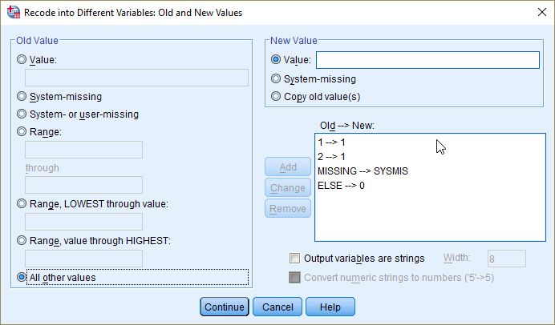
<Figure 1>
Next, dichotomise variables of fepresch, famsuffr and homekid in a way that “Strongly disagree (=5)” or “Disagree (=4)” is recoded as 1 (meaning “Disagree”), missing values as system-missing values, and all other values as 0 (meaning “Do not disagree”). The recoding scheme for these three variables should look like the <Figure 2>.

After finishing the recoding, obtain descriptive statistics for these new four variables. Which variable indicates higher proportion of non-traditional view? On which variable do people tend to hold more traditional view? On which variable do people tend to be more split (meaning people are more equally divided into traditional and non-traditional view)?
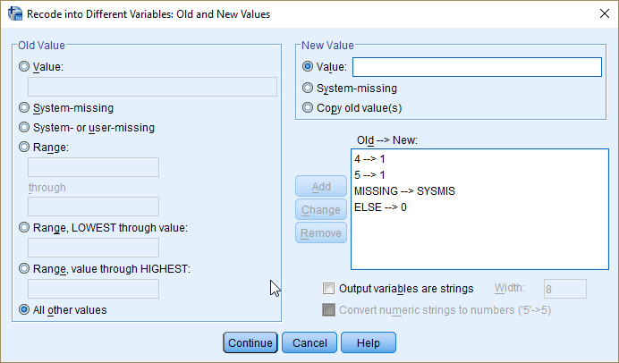
<Figure 2>

Creating an Index of Attitudes toward Working Women by Using the Compute Command
An index of attitudes toward working women is computed by adding up all the recoded four variables, which are named newfechld, newfepresch, newfamsuffr and newhomekid, respectively. And I will call the computed index as indexwkwm. The numerical expression for the index is:

$$indexwkwm=newfechld+newfepresch+newfamsuffr+newhomekid$$

You can make this index using the Compute command (see pp 12—13 in the workshop guide 3 for more detailed instruction). <Figure 3> captures the SPSS screenshot showing how to construct the indexwkwm within the Compute window.
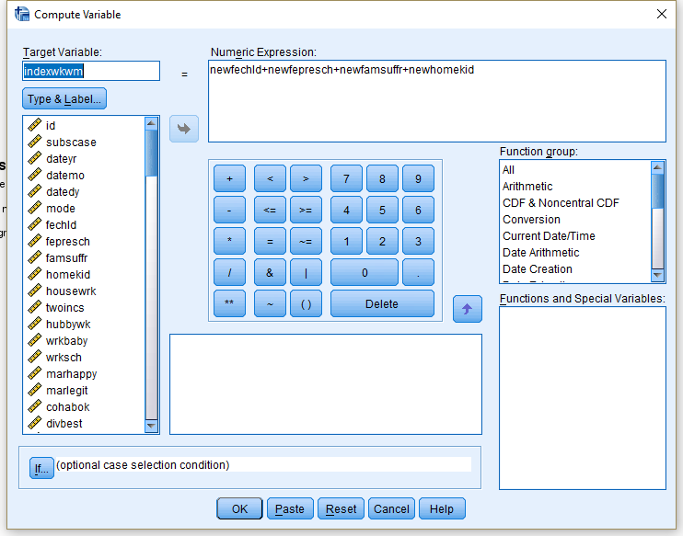
<Figure 3>
Once you make the index, you are ready to do the workshop activities.
Workshop Activities
Q1. Make a frequency table of the new index variable (indexwkwm). How many cases are reported as having missing values? I recommend using the Frequencies command (see pp 21—23 in the workshop guide 1 for more detail).

Q2. Compute descriptive statistics (i.e., mean, median, mode, variance, standard deviation and range) of the new index variable. Report the most relevant measures of central tendency and variability.

Q3. Compare the distribution of this index between men and women (see pp 36—38 in the Week4 lecture slides for the comparison). To answer this question, you may want to compute relevant descriptive statistics and/or draw a relevant graph by gender. And interpret those results. I recommend using the Explore command (see pp 21—24 in the workshop guide 3 for more detail).

